Summary of lectures on the discipline «Applied molecular spectroscopy», specialty «7M05301 - Chemistry»,
2nd course, 2021-2022 (15 lectures)

1-Lecture
Lecture 1-2. Introduction to the theory of molecular spectra.
At present, spectral methods of analysis are the main ones in the study of the composition of matter in various fields of science and technology. The main advantages of spectroscopy over other methods of analysis are:
high sensitivity (10⁵…10⁷%); fairly good accuracy (3…5%);
the rapidity of the time spent is incomparably less than in other methods of analysis;
multicomponent ability to simultaneously determine 20 or more elements;
a small amount of the analyzed sample (up to hundredths of a gram of a substance);
universality, you can define different elements in a variety of objects;
documentation in photoelectric recording or in the photographic version of the method (obtaining a photographic plate), the results of the analysis can be stored for a long time and be a document by which you can repeatedly check the correctness and accuracy of the analysis.
All spectroscopic methods are based on the interaction of electromagnetic radiation with atoms or molecules of the analyzed substance (material).
Spectroscopic methods of analysis are based on the ability of atoms and molecules of matter to emit, absorb or scatter electromagnetic radiation.
With the help of spectroscopic methods, problems of atomic, isotopic, molecular, functional (structural-group) and phase analysis are solved.

2-Lecture
Energy states of the molecule.
The energy structure of a molecule is more complex than that of an atom. Along with the movement of electrons, there is an oscillatory movement of the atoms themselves (more precisely, their nuclei) and the rotation of the molecule as a whole. Therefore, in any stationary state, the energy of molecules is the sum of electronic, vibrational and rotational energies:
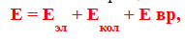
in this case, the greatest contribution to the total energy is made by the energy of electrons:
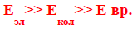
Just like an atom, a molecule can only exist in certain energy states, called energy levels (orbitals). When receiving energy from outside or losing it, the molecule moves from one energy level to another.
If there is no effect on atoms or molecules, which transfers them to an excited state, then they all find themselves at the lowest, basic level (E0), which is the initial level of all absorption lines. If a molecule absorbs radiation, then its energy increases and there is a transition from a lower energy level to a higher one.
To carry out the absorption process, it is necessary that the radiation energy be equal to the difference between the energies of the states of the molecule. The increase in energy in this case is equal to the energy of the absorbed photon.

Lecture 3
Application of the first law of thermodynamics to various processes involving ideal gases.

Thermochemistry. Heat effect of the process. Hess's law
Thermochemistry is a branch of chemical thermodynamics that studies the thermal effects of chemical reactions and processes.
The processes in which heat is released are called exothermic, and the processes in which heat is absorbed are called endothermic.
The thermal effect of a chemical reaction is a measure of the change in energy storage as a result of a given process; it is determined by the sum of the heat released (absorbed) during the reaction and the perfect external work (expressed in the same thermal units) when the molar quantities of a substance * react with each other.
Usually chemical reactions are carried out at constant pressure or constant volume. If during their course there are no other types of work, except for the work of expansion of the system, then at constant pressure, based on (3.17) and (3.18),
Qp  dH , Qp  H , (3.29)
and at constant volume, according to (3.8) and (3.9),
QV  dU , QV  U . (3.30)
The pressure (volume) of the system must be constant from the beginning of the process to its completion, only in this case equations (3.29) and (3.30) will be valid and the heat will be a function of the state. For ideal gas mixtures, the internal energy does not depend on either volume or pressure (U_{V} = U_{p}), and for real gas systems at low pressures, we can take U_{V} ≈ U_{p}.
The heat Q_{p}, expressed by relation (3.29), is called the heat effect of the reaction at constant pressure, respectively, the heat Q_{V} according to (3.30)  at a constant volume.
The thermal effect of a chemical reaction is understood as the amount of heat that is released or absorbed during a chemical reaction under the following conditions:
1) the process takes place at constant pressure or volume;
2) no work is performed in the system, except for the work of expanding the system;
3) the temperature of the reaction products is equal to the temperature of the starting materials.
Under these conditions, the thermal effect becomes a value that depends only on the nature of the ongoing chemical reaction.
Equalities (3.29) and (3.30) as applied to chemical reactions constitute the essence of Hess's law (1840): the thermal effect of a reaction proceeding at constant pressure or constant volume does not depend on the path of the process (intermediate stages), but is determined only by the initial and the final states of the system, i.e. states of initial substances and reaction products.
In other words, the thermal effect of a chemical reaction is equal to a change in the state function: the thermal effect of a process at constant pressure is equal to a change in the enthalpy of the system, and at a constant volume, it is equal to a change in internal energy.
If the reaction proceeds in solution or in the solid phase, where the volume change is insignificant, then
H = U + pV  U. (3.31)
If ideal gases are involved in the reaction, then at constant temperature
H = U + pV = U + nRT, (3.32)
where n is the change in the number of moles of gaseous substances taking part in the reaction:
n  nпрод  nисх , (3.33)
(г) (г)
where  nprod is the number of moles of gaseous reaction products (according to the reaction equation), ref (g)
- the number of moles of gaseous starting materials (according to the reaction equation).
Fourth corollary. The heat effect of the reaction is equal to the difference between the sum of the heats of formation of the reaction products and the sum of the heats of formation of the starting materials:
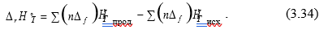
Fifth corollary. The heat effect of the reaction is equal to the difference
between the sum of the heats of combustion of the starting materials and the sum of heats of combustion of the reaction products
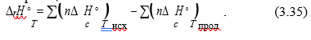
3.3. Heat capacity
The heat capacity of the system is understood as the amount of heat required to heat a unit of the amount of a substance by one degree.
There are several types of heat capacities, the criteria for dividing into which are:
- units of the amount of substance;
- the nature of the thermodynamic process;
- the value of the temperature interval.
Depending on the unit of the amount of substance - 1 kg, 1 m³ and
1 mol - there are three types of heat capacities:
- specific, referred to 1 kg of mass (Sud, J / (kg·K));
- volumetric, referred to 1 m³ of gas under normal physical conditions (Sb, J / (m³·K));
- molar, referred to 1 mol (Сm, J / (mol·K)).
Depending on the nature of the thermodynamic process, isobaric Ср and isochoric СV heat capacities are distinguished, since usually experimental measurements of heat capacities are carried out at р = const and V = const, respectively. The relationship between Cp and CV is given by equation (3.26), and for isothermal processes with the participation of 1 mole of an ideal gas, by Mayer's formula (3.28).
Depending on the size of the temperature interval, there are
average and true heat capacity.
The average heat capacity of a homogeneous system corresponding to a finite temperature range is determined by the ratio
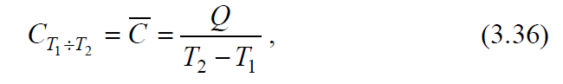
where Q is the amount of heat, due to the receipt (return) of which the temperature of the system rises (falls) from T₁ to T₂.
In this case, it is assumed that heating (cooling) does not lead either to a phase transformation or to a change in the composition of the system.
The true heat capacity is understood as the heat capacity corresponding to an infinitesimal change in temperature (dT), i.e.
where Q – is an infinitesimal amount of heat.
Average and true heat capacities are related by the equation
The narrower the interval (T₂ - T₁), the closer the average heat capacity to the true one.
To determine the true heat capacity from the average, use the ratio
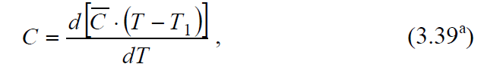
if T₁ = 0 K, then the average heat capacity should be multiplied by the temperature T and differentiated by temperature, i.e. use the equation
Dependence of heat capacity on temperature. The heat capacity of a substance can be considered independent of temperature only in a relatively narrow temperature range. Heat capacity is a complex function of temperature. Usually this dependence is expressed using a power series, the coefficients of which are determined empirically:
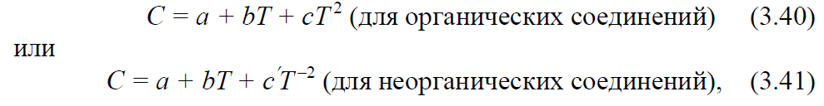
where a, b, c, c, are empirical coefficients valid for a given temperature range.
The coefficients of such series are placed in special tables indicating the temperature range in which the corresponding series gives a good approximation.
The amount of heat spent on heating n mol of a substance from T₁ to T₂ is determined from the ratios:
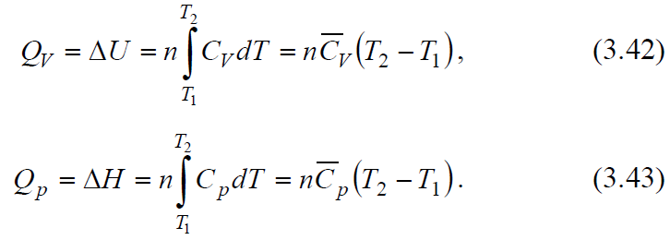
Taking into account that the heat capacity is a function of temperature and is described by the power series (3.40), integrating expression (3.43), we obtain an expression for calculating the amount of heat
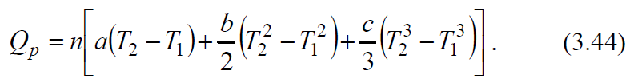
If the specific heat is described by the power series (3.41), then
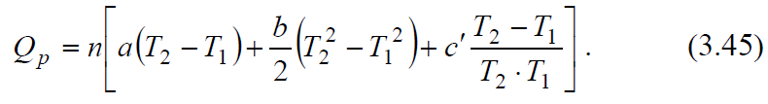
Having data on the dependence of the heat capacity of an individual substance on temperature, it is possible to calculate for it, using equation (3.44) or (3.45), the change in enthalpy upon heating in the temperature range from T₁ to T₂.
Kirchhoff's equations
The equations expressing the dependence of the thermal effect of a chemical reaction on temperature were derived by Kirchhoff in 1858. Kirchhoff's equations in differential form:
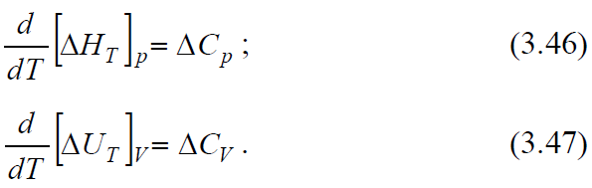
It follows from the Kirchhoff equations that the temperature coefficient of the heat effect of the process is equal to the change in the heat capacity of the system that occurs as a result of the process.
Equation (3.46) is strictly valid only under the condition that the pressure above each of the components at the desired temperature will be the same as at the given temperature. From (3.46) it follows that the sensitivity of ΔH to a change in T is determined by the absolute value of ΔCр, and the sign of the temperature coefficient of the thermal effect is determined by the sign of ΔCр.
At Ср> 0, the thermal effect of the reaction increases with increasing temperature, at Ср <0 it decreases, at Ср = 0 it does not depend on temperature. It should be noted that the ΔСр sign is also associated with the choice of the sign of thermal effects.
The nature of the change in H with a change in temperature is due to the nature of the change in Cр with T. 3.1 schematically depicts all possible cases, except those when ΔH is a linear function of temperature. The extremum on the ΔH = f (T) curves is observed relatively rarely, since usually the temperature ranges are not very large. However, the very possibility of the appearance of an extremum serves as an indication of the inadmissibility of significant extrapolation of the temperature dependence of the thermal effect beyond the experimental data or guaranteed accuracy of the formulas.
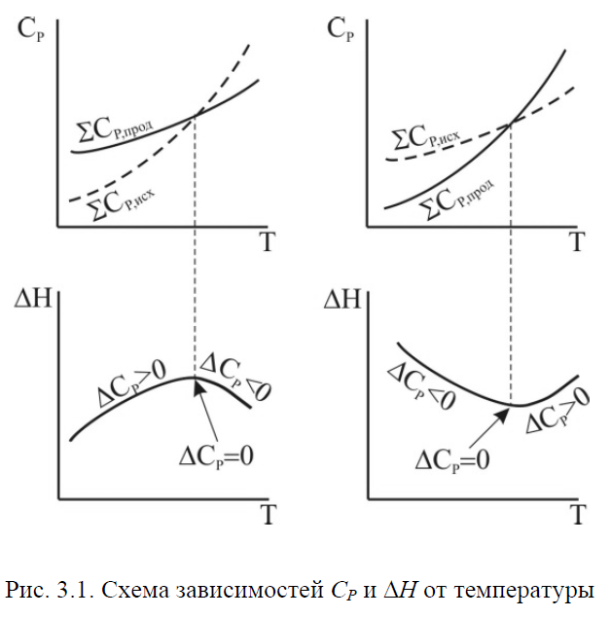
To calculate the thermal effect of the process at p = const, it is necessary to integrate equation (3.46) in the temperature range from T₁ to T₂, i.e.
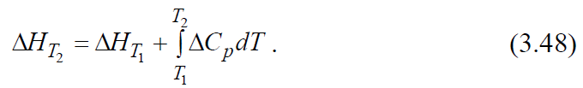
A similar expression is obtained for the heat effect of the process at constant volume (from equation (3.47)):
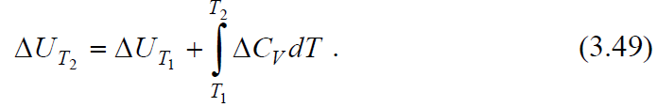
When using equations (3.48) and (3.49), it should be borne in mind that in the temperature range from T₁ to T₂ there should be no phase transitions of the substances participating in the reaction.
Thus, knowing the heat effect of the reaction at one temperature T₁, one can find it at another temperature T₂, if the heat capacities and their dependence on temperature in this temperature range are known.
When calculating ΔH, several degrees of approximation can be considered:
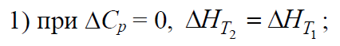
3) if the dependence of the heat capacity of each substance is expressed in the form of power series (3.36) and (3.37), then for the reaction
is also expressed as a series
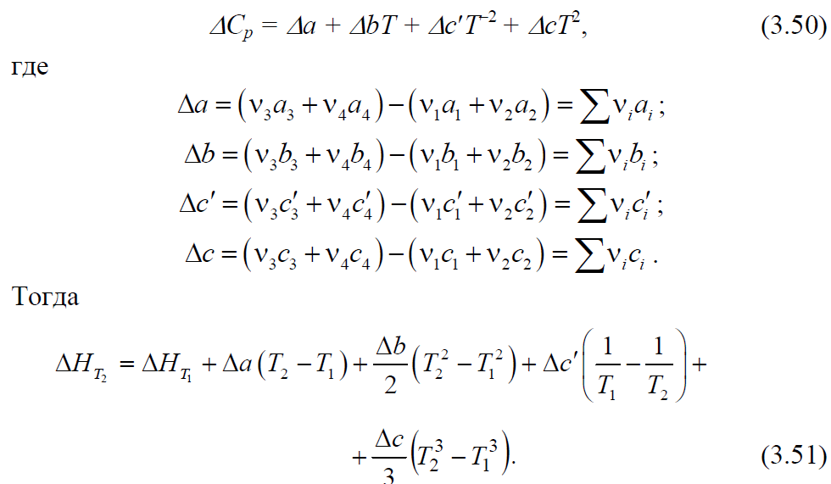
ΔU is calculated similarly.

Lecture 4
The second law of thermodynamics, its concepts. Carnot cycle and Carnot's principle. Efficiency of an ideal heat engine. Entropy.
The conclusion about the insufficiency of the first law of thermodynamics to determine the direction and limit of the course of processes led to the establishment of the second law of thermodynamics. Many formulations of the second law, equivalent to each other, are known. One of the first is the Carnot – Clausius theorem, which proves that the efficiency (η) of a heat engine when operating according to a quasi-static Carnot cycle and the highest possible efficiency is a heat engine, regardless of the type of the working body, is expressed by the ratio
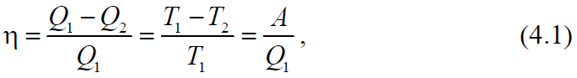
where Q₁ is the amount of heat imparted at the temperature T₁ to the working fluid from the heat source, Q₂ is the amount of heat given by the working fluid at the temperature T₂ to the refrigerator, A is the work done by the system.
Carnot's formulation: to convert heat into work, you must have two sources of heat of different temperatures.
Clausius' postulate: a process is impossible, the only result of which would be the transfer of heat from a colder body to a hotter one (this process is called the Clausius process).
Thomson's (Kelvin's) postulate: a circular process is impossible, the only result of which would be the production of work by cooling the heat reservoir (this process is called the Thomson process).
Ostwald's formulation: a perpetual motion machine of the second kind is impossible.
Boltzmann's formulation: all natural processes are a transition from a less probable state to a more probable one.
The Carathéodory principle: near any state of thermodynamic equilibrium and arbitrarily close to it, there is a state that cannot be reached by an adiabatic process.
The second law of thermodynamics establishes the direction and conditions for the course of natural processes. Just like the first law of thermodynamics, it was established on the basis of experimental data.
Entropy. Calculation methods
From the classical formulations of the second law of thermodynamics (Carnot, Clausius, Thomson, Ostwald), as well as from the Carathéodory principle, it follows that a thermodynamic system has a new function of state S, some extensive property called entropy, the change of which is related in the following way to the absorbed heat and system temperature:
- in a spontaneous process
- in an equilibrium process
- in a non-spontaneous process
Combining relations (4.2) - (4.4), expressing the second law of thermodynamics for reversible and irreversible processes, we can write
where the equal sign refers to reversible processes, and the greater than sign refers to irreversible processes.
In an isolated system (U = const, V = const), equation (4.5) has the form
and entropy is a criterion of equilibrium and spontaneity of the process, i.e. the entropy of isolated systems in irreversible processes can only increase, and in the state of thermodynamic equilibrium it reaches a maximum (dS = 0, d²S <0).
In a reversible process, when the system passes from state 1 to state 2, i.e. with a finite change in the state of the system, the change in entropy is determined by the equation
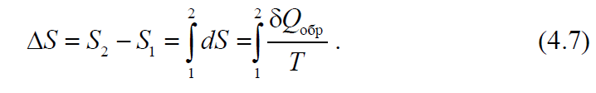

For isothermal process
For reversible processes in an isolated system, δQ_{rev} = 0

Lecture 5
Entropy is a criterion for the direction of the process (constructive condition). Equations for calculating the change in entropy in various processes. Planck's postulate.
Calculation of entropy change in heating or cooling processes
The change in entropy during heating (or cooling) of various substances from temperature T₁ to T₂ at constant volume or constant pressure is determined from equation (4.7). Taking in
attention that 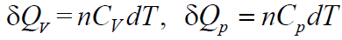 we obtain
and integration under the condition C_{V} = const or C_{p} = const gives
where n is the number of moles of substances.
Taking into account the dependence of heat capacity on temperature
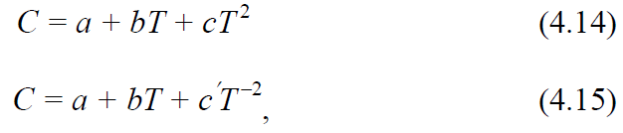
equations (4.10) and (4.11) are written in the form
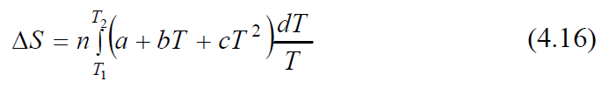
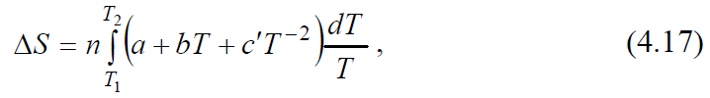
and after integration are presented in the form of the following formulas for calculating ΔS:

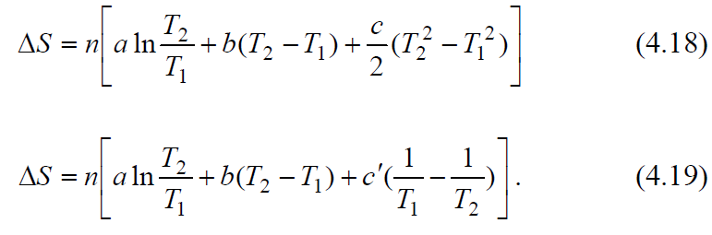
Calculation of entropy during phase transitions
During phase transitions (melting, evaporation, etc.), if the pressure remains constant, the change in entropy (taking into account equation (4.8) and temperature constancy during phase transitions) is calculated by the formula

Where Hф.п. – the heat of the phase transition. For n mol, formula (4.20) rewritten as
In the general case of a reversible process at constant volume, when the change in internal energy is equal to ΔU, or at constant pressure, when the change in enthalpy is equal to ΔН, the change in entropy is:
Change in the entropy of an ideal gas. Diffusion of gases
The change in entropy during the transition of n mol of an ideal gas from one state to another is calculated from the combined equation of the first and second laws of thermodynamics:
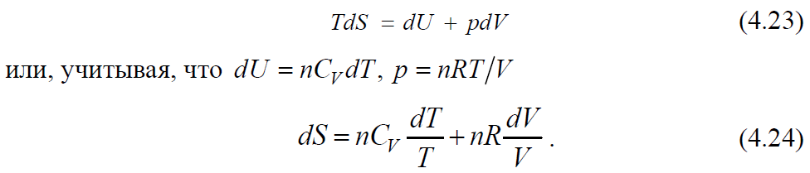
When integrating, assuming the constancy of the specific heat, we have
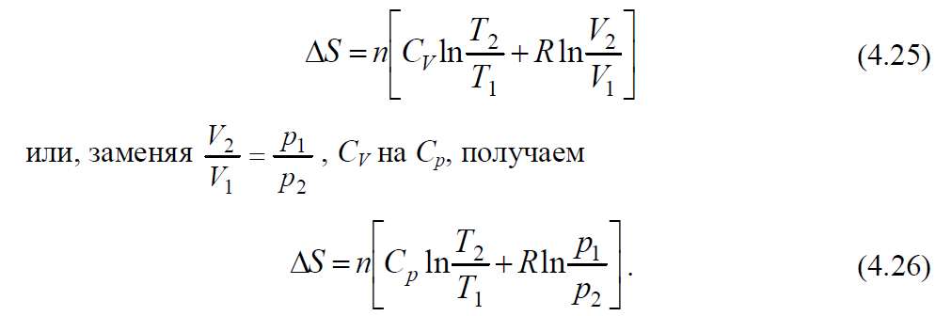
Taking into account the dependence of the heat capacity on temperature, we obtain equations (4.27) and (4.28):
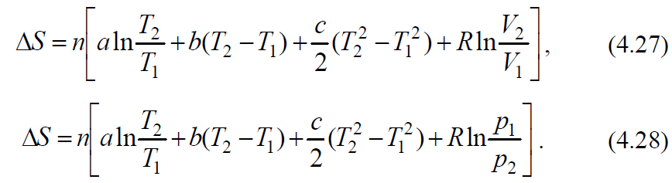
Using the corresponding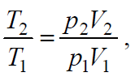can be calculated by the formula

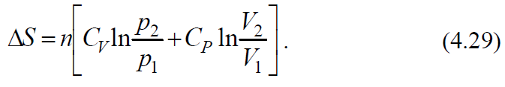
The change in entropy during the adiabatic expansion of an ideal gas is determined by the equation
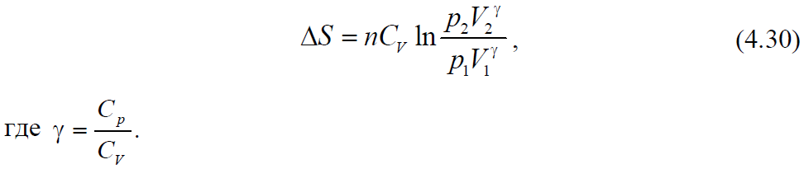
The change in entropy for the processes of isothermal expansion or contraction can be calculated using Maxwell's equations (1):
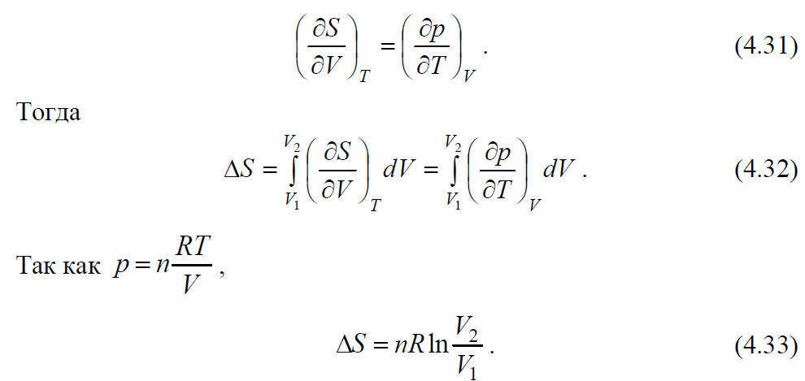
If we use Maxwell's equation (2):
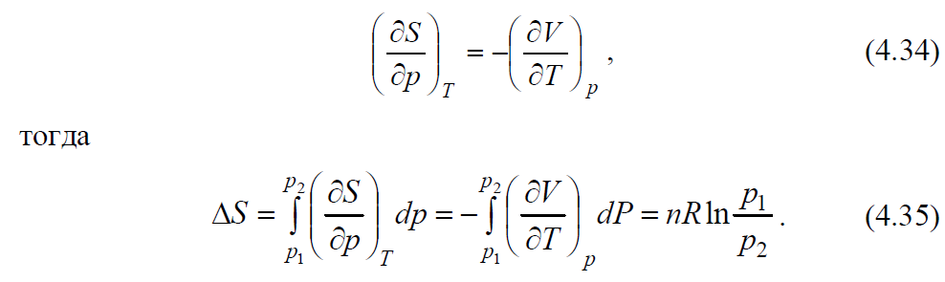
The same result can be obtained if we use the expression for the heat of isothermal reversible expansion of an ideal gas (see Table 3.1)
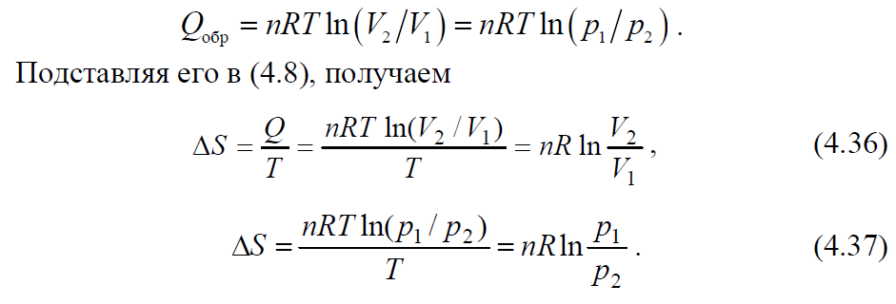
In the process of diffusion during mixing of ideal gases (at p = const and T = const), i.e. in an isobaric-isothermal process, the change in entropy is calculated by the equations
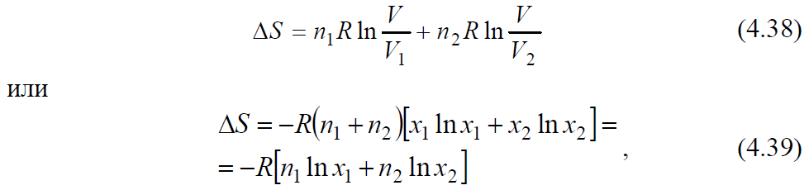
where n₁, n₂ is the number of moles of the first and second gases; х₁, х₂ - molar fractions of both gases; V₁, V₂ - initial volumes of gases; V is the final volume of the gas mixture (V = V₁ + V₂).
The absolute value of entropy
The absolute entropy S ∘ is calculated by the equation
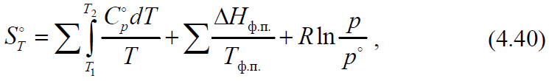
where the first sum expresses the change in entropy in the process of heating a solid, liquid or gaseous substance from one temperature to another, and in the case of a solid, the first temperature is zero degrees Kelvin; the second sum is the change in entropy during phase transitions (melting, evaporation, sublimation);
change in entropy during expansion (compression) of saturated steam from equilibrium pressure to standard pressure 1.013 · 105 Pa.
In expanded form, equation (4.40) has the following form
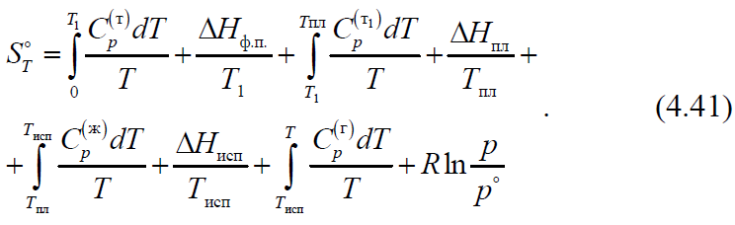
Calculation of the entropy of chemical reactions
For a chemical reaction, the change in entropy ΔrS is calculated by the equation
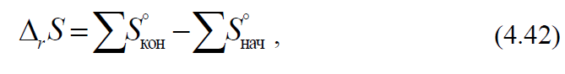
where S∘ is the sum of the absolute entropies of the final and initial substances, taking into account the stoichiometric coefficients of the reaction.
If the change in entropy at temperature T₁ is known, then the change in entropy at temperature T₂ can be found by the formula
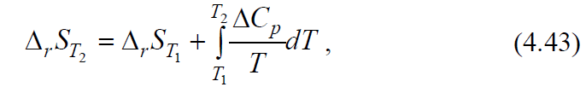
where ΔCp is the difference between the sums of the heat capacities of the reaction products and the initial substances.
In the presence of phase transitions in the temperature range T₁ - T₂ it is necessary to take into account the equation (4.20)
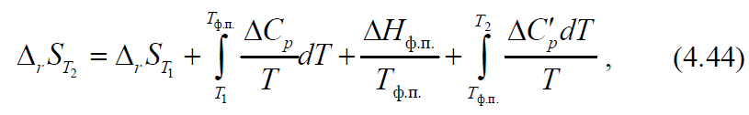
where ΔCp andΔСp
- the difference between the sums of the heat capacities of the reaction products and the initial substances in the temperature range before and after the phase transition.
Calculating the entropy of chemical reactions using electrochemical data
Using electrochemical data, the entropy change can be calculated using the equation
where ∆Н is the thermal effect of a chemical reaction; F is the Faraday number; E is the electromotive force (EMF) of the electrochemical cell in which this reaction takes place; z is the number of electrons participating in the electrode reaction per one reacting particle

Lecture 6
Thermodynamic potentials. Characteristic functions and their natural variables. Comparative characteristics of thermodynamic functions (ΔU, ΔH, ΔS, ΔF, ΔG) as a criterion for the direction of the process.
Thermodynamic potentials and characteristic functions
The combined equation of the first and second laws of thermodynamics - the fundamental Gibbs equation - is the basis of the mathematical apparatus of thermodynamics. For reversible processes, it is written in the form
where Хk are other coordinates of the state, except for S and V, and Рk are generalized forces except for Т and p. Comparison of equation (4.46) with the expression for the total differential of the internal energy
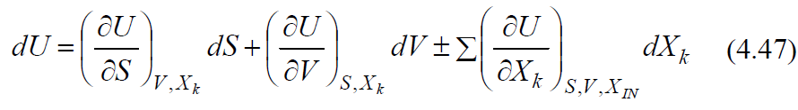
shows that all generalized forces are partial derivatives of the function U with respect to the coordinates Xk
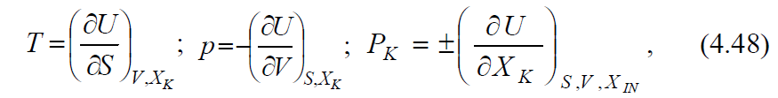
where the index IN means the constancy of all coordinates XI, except for Xk

Lecture 7
Chemical potential, its relationship with thermodynamic functions and composition of the system. Chemical potential of a component in ideal and real solutions. Activity, activity coefficient.
When solving specific problems, equations (4.46) - (4.47) usually turn out to be inconvenient, since entropy, which is inaccessible for experimental determination, has to be considered as an independent variable. Therefore, the fundamental equation (4.46) is transformed to other variables using the Legendre method known in mathematics. Since РkХk is a state function, any auxiliary function of the form Ф = U - ΣРkХk is also a state function. The substitution H = U + pV leads to the replacement of V by p and we have the equation
The substitution F = U - TS leads to the replacement of S by T. This determines the Helmholtz energy F and its differential
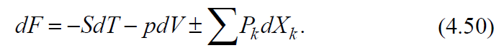

Lecture 8
Homogeneous equilibrium, its features and conditions. Isothermal equations of chemical reactions and directions of processes for various homogeneous systems. The law of mass interaction and the equilibrium constant of a chemical reaction.
The replacement of S by T and, at the same time, V by p is carried out by the substitution G = U - TS + pV, which leads to the consideration of the Gibbs energy G as another function of the state
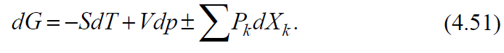
Each of the equations (4.49) - (4.51) is the combined equation of both principles of thermodynamics, transformed to other independent variables.
For closed systems in which only mechanical work is performed, equations (4.46), (4.49) - (4.51) have the form
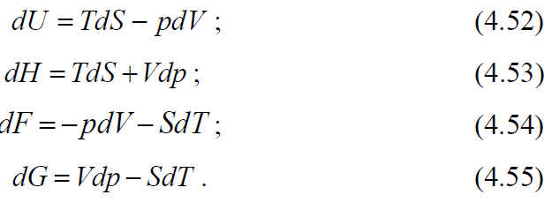

Lecture 9
Temperature dependence of the equilibrium constant. Isobaric and isochoric Van't Hoff equations.
The most complete information about all properties of the system is given by each of these functions, if it is defined explicitly in terms of "Natural" - specified in brackets - variables:
These functions are characteristic. A function in thermodynamics is called characteristic if its values ​​and the values ​​of its derivatives are sufficient for a complete description of the system, that is, to find the numerical value of any quantity of interest to us, to establish the relationship between the measured quantities. Of the many characteristic functions, five — U, H, F, G, and S — have acquired the greatest significance in thermodynamics, and in specific thermodynamic calculations, two — Helmholtz energy and Gibbs energy, since their natural variables are most convenient for chemistry. Another (outdated) name for these functions is isochoric-isothermal and isobaric-isothermal potentials.
Various properties of the system are expressed in an explicit form through the derivatives of different orders of characteristic functions. From equations (4.52) - (4.56) we will have:
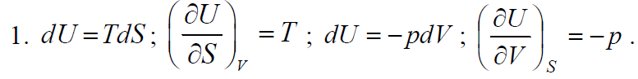
If the obtained derivatives are differentiated again, but each with respect to a different natural variable of the given function, mixed second derivatives are obtained, the equating of which makes it possible to obtain Maxwell's equation
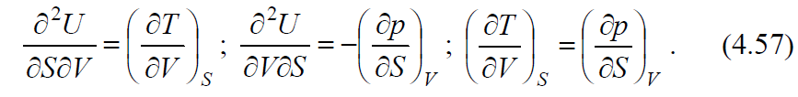

Lecture 10
Phase, components, constituent. Heterogeneous chemical systems, equilibrium conditions in them. Gibbs Phase Rule. Clapeyron-Clausius equation. Description of the state of the water diagram by the Clapeyron-Clausius equation and the Gibbs phase rule. Phase transitions of types 1 and 2, their features.
Similarly, we will carry out mathematical operations with respect to other characteristic functions:
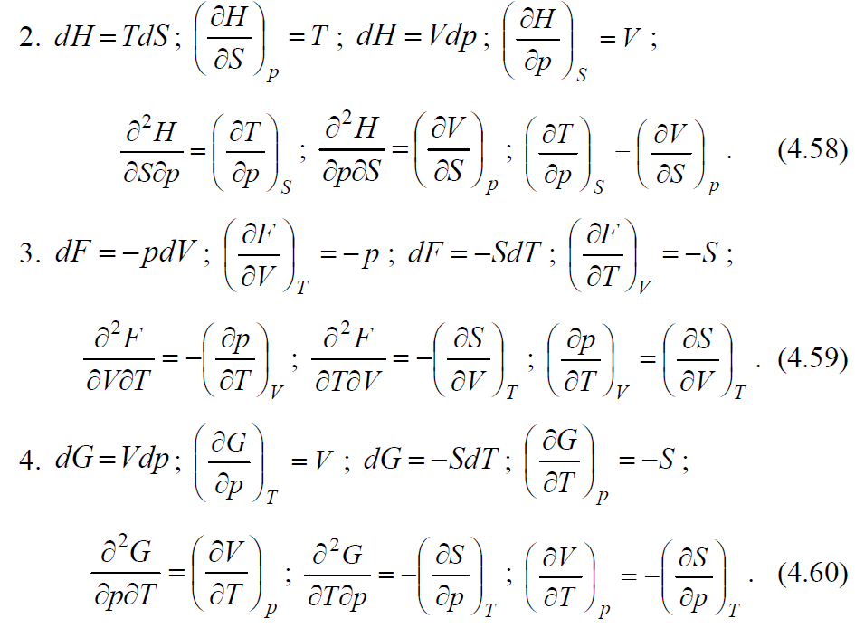
Using the described transformations, we obtain the Maxwell equations:
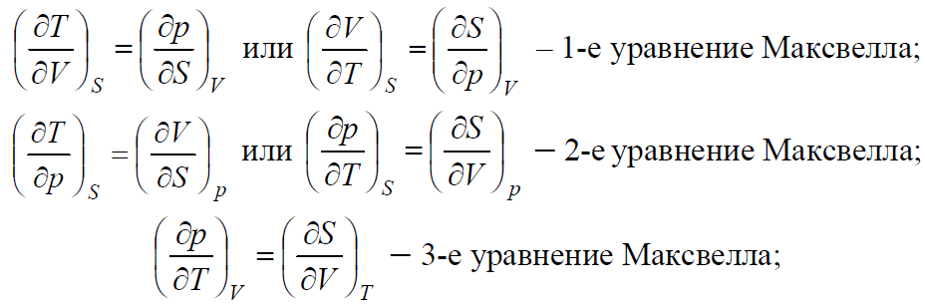
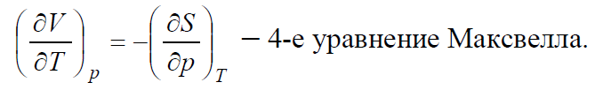
Lecture 11
Melting diagram of a two-component system: one-eutectic systems, systems in which components interact chemically (forming compounds with congruent and incongruent melting points). Solid solutions, their formation by penetration and displacement. Melting diagram of solid solutions. Gibbs-Rosebohm Rules I and II.
All four obtained Maxwell's equations are convenient in that the derivatives of entropy, which are difficult to obtain, are replaced by derivatives of pressure or volume from temperature. Maxwell's equations, especially the last two, find various applications in physical chemistry.
If the system is open and exchanges matter and energy with the environment (a chemical reaction occurs in the system), then it is necessary to take into account the dependence of thermodynamic potentials on the amount of substances ni. Then equation (4.47) is represented in the form
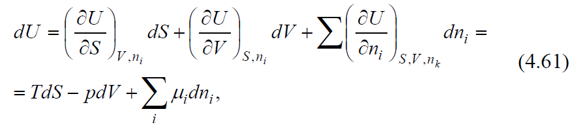
where ni is the amount of substance of the i-th component, and the symbol nk means the constancy of all nk, except for ni.
The internal energy in this case is a function of the volume, entropy and masses of the components and is written as 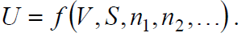
Similarly, for other potentials, we obtain the equations
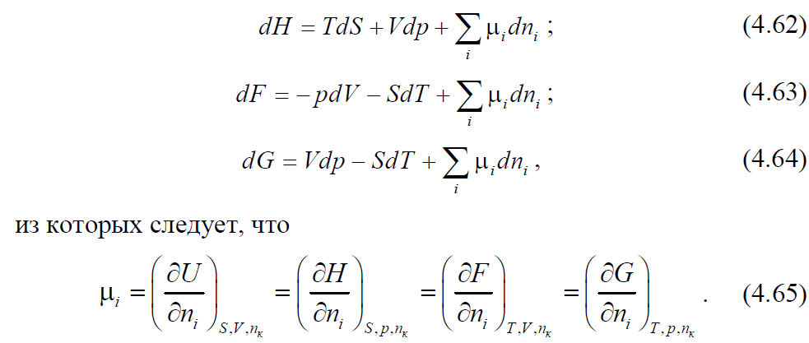

Lecture 12
Solubility of two and three liquids in each other. Methods for displaying the composition of a three-component system. Tarasenkov's rule. Crisis melting points. Extraction.
The function μ is called the chemical potential, which characterizes the increment of the thermodynamic potential when the amount of a given substance changes with fixed natural variables and unchanged amounts of other substances.
If any other work related to mass transfer is performed in the system, then the concept of “total potential” is introduced. These include, for example, the electrochemical potential of the i-th component
where 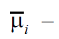F, (4.66) - full potential; F - Faraday number, φ - potential difference
In the general case, the total potentials are derivatives of the functions U, H, F, G with respect to independent coordinates.
The considered thermodynamic functions and potentials make it possible, under certain conditions, to predict the direction of the thermodynamic process. General conditions of thermodynamic equilibrium and spontaneous course of the process are presented in table. 4.2.

Lecture 13
Thermodynamic properties of ideal liquid solutions. Real solutions. Raoult's law. Thermodynamic substantiation of the linear dependence of the total and partial vapor pressure on the composition of the system for ideal systems.

General conditions for the equilibrium of thermodynamic systems
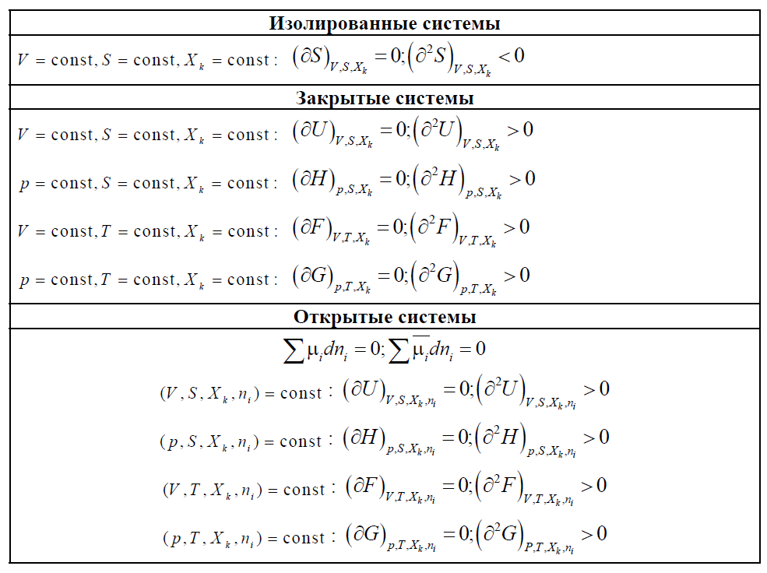
Lecture 14
Boiling point (vapor pressure) - composition (t, P - x) diagrams. Gibbs-Konovalov laws I and II.
The decrease in the Helmholtz energy in any process at T = const, V = const is equal to the maximum mechanical work that the system can perform in this process

Thus, the energy F is equal to that part of the internal energy (U = F + TS) that can turn into work.
Similarly, the decrease in the Gibbs energy in any process at T = const, p = const is equal to the maximum useful (ie, non-mechanical) work that the system can perform in this process

Lecture 15
Ebuliometry. Cryometry. Determination of the molecular weight and molecular state of the solute from cryometric or ebuliometric data. Isotonic Van't Hoff coefficient.
The dependence of the Helmholtz (Gibbs) energy on the volume (pressure) follows from the basic equation of thermodynamics (4.54), (4.55):
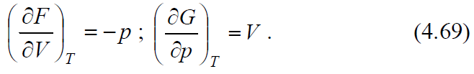
The temperature dependence of these functions can also be described using the same equations:
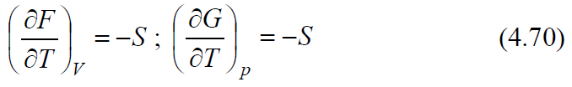
or using the Gibbs – Helmholtz equation
